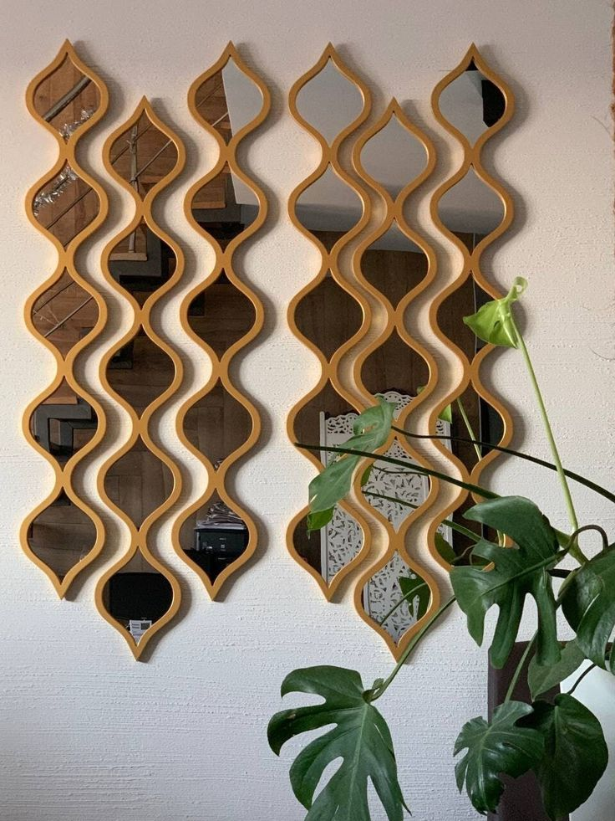**✨ Modern Clarity with Lightweight Acrylic Mirrors**

Acrylic Mirrors offer a sleek, shatter-resistant alternative to traditional glass, making them perfect for modern, busy households. Known for their lightweight build and high impact resistance, these mirrors are ideal for homes with children, rental spaces, or creative interior setups.

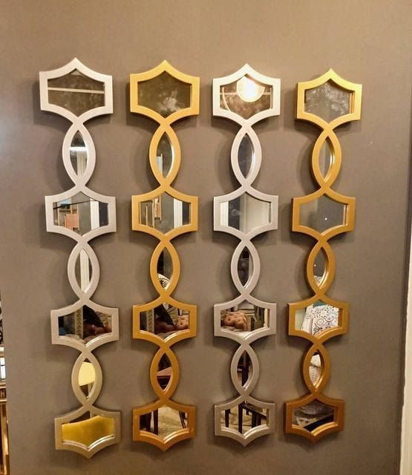

Unlike glass, acrylic mirrors are flexible and easy to mount on walls, doors, or even ceilings. Their clear, reflective surface delivers excellent clarity while being significantly safer and more durable in high-traffic areas.

Available in various shapes, sizes, and finishes, acrylic mirrors lend themselves beautifully to custom designs — whether you want a minimalist frameless look or a bold geometric statement. They're also great for DIY décor projects and commercial interiors where both safety and style are key.

Choose acrylic mirrors to bring modern aesthetics, safety, and versatility into your space — smart design that reflects your lifestyle.